DATE: 07.06.2019
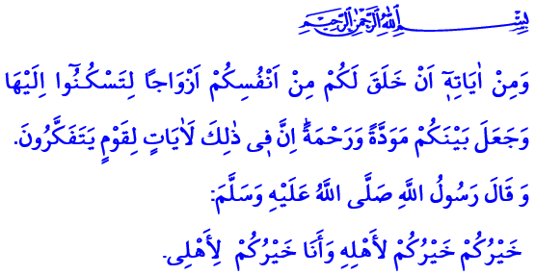BEING A FAMILY AND REMAINING AS
A FAMILY
Honorable Muslims!
Allah the Almighty (swt) states in the verse I have just recited: “And among His Signs is this, that He created for you mates from among yourselves, that ye may dwell in tranquility with them, and He has put love and mercy between your (hearts): Verily in that are Signs for those who reflect.”
The Prophet Muhammad (saw) said in the hadith I have read: “The best of you is he who is best to his family, and I am the best among you to my family.”
Dear Believers!
Allah the Exalted (swt) sent human, the most precious being, to this world in two different genders as man and woman. He created a strong bond of love and compassion between them to be spouses and to start a peaceful family. He bestowed upon them a family atmosphere in which they can cooperate in benevolence and feel safe.
Honorable Muslims!
Getting married and establishing a family, first of all, inheres in human nature by creation. While Allah the Exalted (swt) encourages marriage for man and woman with the command “Marry those among you who are single.”, He also advises the whole society, especially their relatives, to support those who are in the age of marriage.
Starting a family is also a Sunnah of our Prophet (saw). The Messenger of Allah (saw) said in a hadith: “Marriage is part of my Sunnah, and whoever does not follow my Sunnah has nothing to do with me.” It is an honor and reason for gratitude for every human being to have a decent marriage by correct way and in a manner appropriate to his nature. Because our Prophet (saw) stated, “O young men, whoever among you can afford to get married, let him do so.”, and expressed, “Marriage is the best way to turn eyes away from haraam, and protect the honor.”
Dear Believers!
Living in a family is a blessing that gives trust and happiness to people of all ages. What other blessing can substitute for the taste of a warm home, its affectionate hand that solves one’s problems, and its support that adds meaning to life? Spouses who build their family life on sound grounds will be happy not only in this world but also in the Hereafter, and they will take each other to heaven.
Being a family does not mean just living under the same roof. Family is also a togetherness in feeling, ideal, hope, and thought. It means spouses to be friends and compete in benevolence and taqwa. Being a family is to live a life that complies with the consent of Allah (swt). It is to share both joy and grief, and both richness and poverty. It is to overcome all kinds of difficulties together and to be a compassionate spouse, a loyal lover, a merciful parent, and a good child.
Honorable Muslims!
Remaining as a family is as much important as starting a family. To value and protect one’s family are the duties of every male and female Muslim. Remaining as a family means that the spouses cover each other like a garment, protect each other from all kinds of evil, and integrate each other with love and care. For this reason, the Almighty Allah (swt) states: “They are your garments and ye are their garments.”
Remaining as a family requires leaving the mistakes and flaws that threaten home. A believer tries to be tolerant and forgiving, and act in a patient and persistent manner in his/her family. In this regard, our Beloved Prophet (saw) recommends: “A Muslim man must not bear hatred against his Muslim wife as she has an unlikeable temper; because she must have many other tempers that he will like.”
Remaining as a family is possible only if each woman, man, elder person, and young person fulfill their responsibilities and observe the rights of others as well as their own rights. It requires thinking about the benefits of the family under any circumstance rather than one’s own interest. Our Prophet Muhammad (saw) says, “It is enough sin for a man not to give food to the one whom he is supposed to feed.”
Dear Believers!
Let us exert efforts to have a family where love and joy get barakah and sadness and sorrow disappear. Let us introduce our youth to a family’s strong and sincere spirit. Let us present a family atmosphere that will give peace to our children and spouse. Let us appreciate the value of our family. Let us remember that our family is the trust of Allah (swt), and that people will firstly account for their behavior towards their parents, spouses, and children in the Hereafter.

Rum, 30/21.
Tirmidhi, Manaqib, 63.
Nur, 24/32.
Ibn Majah, Nikah, 1.
Bukhari, Nikah, 3; Muslim, Nikah, 1.
Bukhari, Nikah, 3; Muslim, Nikah, 1.
Baqarah, 2/187.
Muslim, Rada’, 61.
Abu Dawud, Zakat, 45. General Directorate of Religious Services

